**Objective Questions**

1. **What is the total no. of tables present in the data?**

|  |  |
| --- | --- |
| **Table Name** | **Reference** |
| Raw Data | **'Raw Data'!A1:U9552** |
| Country Description | **'country description'!A1:B16** |

1. **What is the total no. of attributes present in the data?**

**Attributes in Total:** 20

**Reference: 'Raw Data'!A1:U1**

1. **How many categorical columns are there in the data? [Search about categorical and continuous data, and try to answer this question**

15 columns are categorical in the given data.

**RestaurantID, RestaurantName, CountryCode, City, Address, Locality, LocalityVerbose, Cuisines, Currency, Has_Table_booking, Has_Online_delivery, Is_delivering_now, Switch_to_order_menu, Price_range, Rating**

1. **The data consists of some inconsistent and missing values so ensure that the data used for further analysis is cleaned.**

**Approach Used**: Used filter to identify missing values in columns.

Replace missing values in “Cuisines” column with a placeholder “Not Specified”.

1. **Using the LookUp functions, fill up the countries in the original data using the country code**

**Reference:** 'country description'!A1:B16

**Approach Used:** VLOOKUP Function

**Formula:** VLOOKUP(C2,'country description'!$A$1:$B$16,2,0)

.

1. **Create a table to represent the number of restaurants opened in each country.**

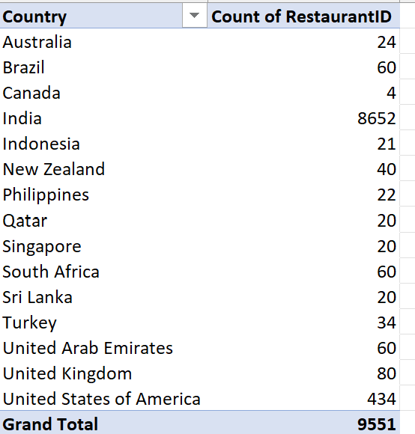

**Approach Used:** Pivot Table

**Insights:** Most of the restaurants are situated in India, Number of restaurants in most of the countries is around the same range.

1. **Also, the management wants to look at the number of restaurants opened each year, so provide them with something here.**

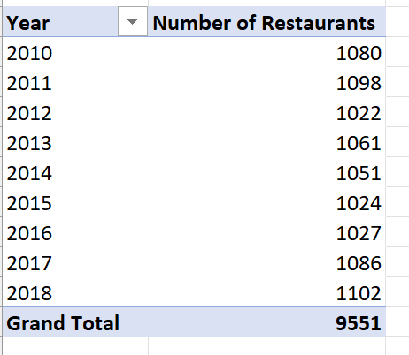

**Approach Used:** Pivot Table

**Insights:** There is no major change in the number of restaurants opened each year.

1. **What is the total number of restaurants in India in the price range of 4?**

**Number of restaurants in the price range 4:** 388

**Approach Used:** Aggregation Function **countifs()**

**Insights:** Only 4.06% of restaurants are in the highest price range.

1. What is the average number of voters for the restaurants in each country according to the data?

|  |  |
| --- | --- |
| Australia | 111.4166667 |
| Brazil | 19.61666667 |
| Canada | 103 |
| India | 137.212552 |
| Indonesia | 772.0952381 |
| New Zealand | 243.025 |
| Philippines | 407.4090909 |
| Qatar | 163.8 |
| Singapore | 31.9 |
| South Africa | 315.1666667 |
| Sri Lanka | 146.45 |
| Turkey | 431.4705882 |
| United Arab Emirates | 493.5166667 |
| United Kingdom | 205.4875 |
| United States of America | 428.2211982 |

**Approach Used:** Pivot Table (Country and Average of voters)

**Insights:** Indonesia has the highest number of voters by a great margin from the other countries.

1. Calculate the average rating for all the restaurants that have price_range < 4 and provide online delivery. Use only the “IF” function, Logical Operators, and Aggregation functions to solve this problem. **[Note: Don’t use Conditional aggregation in this question.]**

**Avg rating of restaurants with price range<4 and online delivery:** 3.27381151

**Approach Used:** Count function with a helper column.

**Insights:** The high rating demonstrates that customers prioritize online delivery service in their restaurant selection.

1. Using Conditional formatting highlight the rows of restaurants that are located in the countries or cities that you’ve suggested to the management for opening new restaurants.

**Approach Used:**

Used conditional formatting for highlighting the rows representing restaurants in the countries that have been selected for opening new restaurants.

**Cell Styles** are used to highlight the aforementioned rows.

1. Create a new customized price column that consists of the abbreviation/symbol of the currency along with the Average_cost_for_two value. [Use string operations to do this task]

**Approach Used:** String Operation Function

**Formula Used:**

**=CONCAT(MID(L2,SEARCH("(",L2)+1,SEARCH(")",L2)-SEARCH("(",L2)-1),S2)**

1. How can you create an array formula in Excel or Google Sheets to count the number of restaurants listed that do not offer online delivery, are in the lowest price range, and have an average cost for two people less than or equal to 250 Indian Rupees?

**By using the following Array Formula in the Sheet**

**{=SUM(('Raw Data'!N1:N9552="No")*('Raw Data'!Q1:Q9552=1)*('Raw Data'!Z1:Z9552<=250))}**

**Approach Used: Array Formula where Column Z contains the average cost for two converted into INR from the different currencies**

**number of restaurants listed that do not offer online delivery, are in the lowest price range, and have an average cost for two people less than or equal to 250 Indian Rupees: 1694**

**Subjective Question:**

1. **Suggest a few countries where the team can open newer restaurants with lesser competition. Which visualization/technique will you use here to justify the suggestions?**

**Reference:**

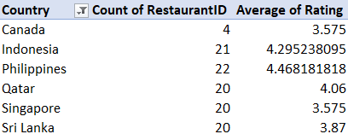

**Approach Used:** Pivot Table for the lowest number of restaurants along with their average rating.

**Insights:** The above 6 countries are being chosen for opening new restaurants due to a smaller number of restaurants already there and hence less competition while also having good average rating.

1. **Come up with the names of States and cities in the suggested countries suitable for opening restaurants.**

**Reference:**

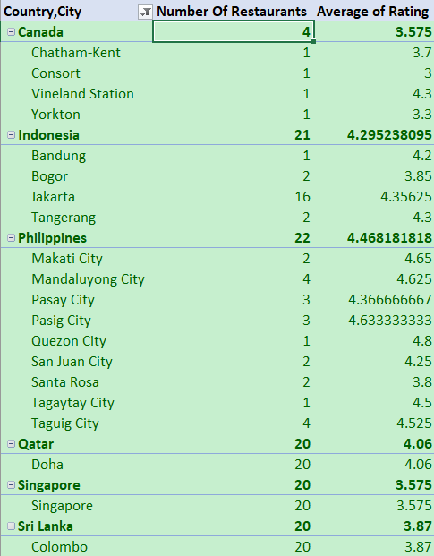

**Approach Used:** Pivot Table and Conditional Formatting.

**Insights:**

3 of the countries have only 1 city with data available.

Philippines has a very high average rating in regards to the high number of restaurants.

1. **According to the countries you suggested, what is the current quality regarding ratings for restaurants that are open there?**

**Reference:**

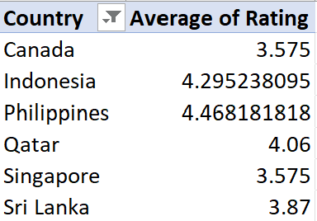

**Approach Used:** Pivot Table with filters

**Insights:** Philippines and Indonesia are on the higher end of customer service while Canada and Singapore are on the lower end.

1. **Also, what is the current expenditure on food in the suggested countries, so we can keep our financial expenditure in control?**

**Reference:**

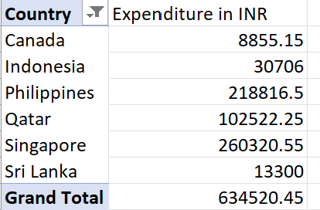

**Approach Used:** Pivot Table

**Insights:** Singapore has the most expenditure on food among the chosen countries while Sri Lanka has the least expenditure.

1. **Come up with the names of restaurants from the recommended states that are our biggest competitors and also those that are rated in the lower brackets, i.e. 1-2 or 2-3.**

**Biggest Competitors (with the highest Rating)**

**Reference:**

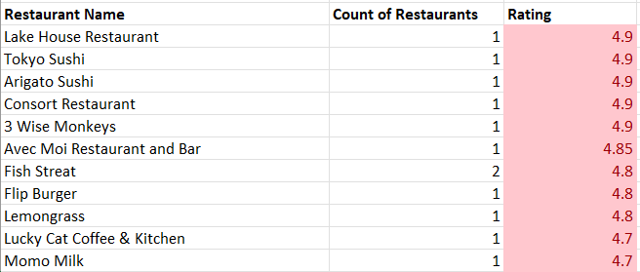

**Low Rated Restaurants**

**Reference:**

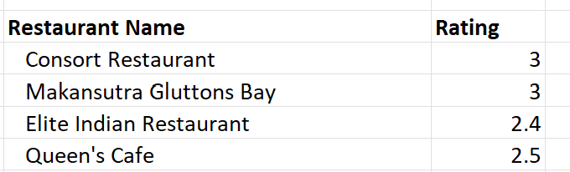

**Approach Used:** Pivot Table, Conditional Formatting to highlight the top 10 restaurants according to their ratings in the chosen countries.

**Insights:** The number of restaurants at 1-2,2-3 rating is very low, the restaurants of the selected countries have good customer service.

1. **Which cuisines should we focus on in the newer restaurants to get better feedback? Does the choice of cuisines affect the restaurant ratings?**

**Reference:**

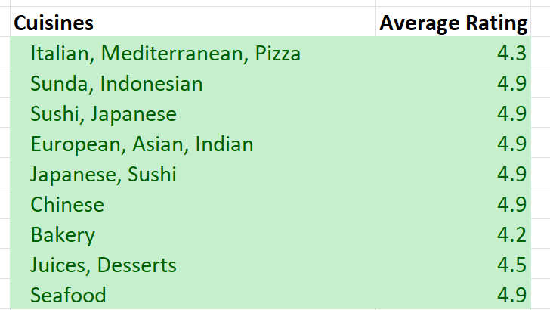

**Approach Used:** Pivot Table

**Insights:** The choice of cuisines doesn’t have that much of an effect on restaurant ratings since the standard deviation of the ratings is very low.

1. **According to our current data, should we go for online delivery and table booking? Does that affect the customer’s ratings?**

**Reference:**

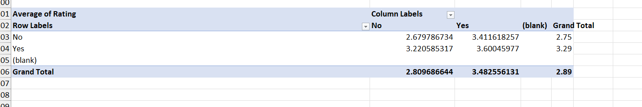

**Approach Used:** Pivot Table

**Insights:** Restaurants with online delivery and table booking have higher rating than the restaurants that do not provide those services so we should absolutely go for these provisions.

1. **Should the team keep the rate of cuisines higher? Will that affect the feedback? According to our data are the rates of cuisines and ratings, correlated?**

**Reference:**

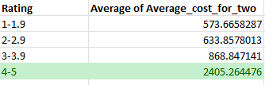

**Approach Used:** Pivot Tables & Conditional Formatting to highlight the high rating bracket.

**Insights:**

* The rate of cuisines certainly starts increasing with number of cuisines and is highest at 6 cuisines.
* The rate of cuisines must be kept higher in order to ensure better feedback.

1. **What is the distribution of the number of restaurants of different price ranges in all the countries?**

**Reference:**

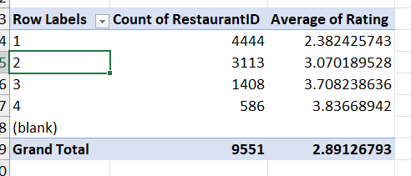

**Approach Used:** Pivot Table

**Insights:** The average rating of restaurants is the highest with the highest price range.

1. **Explain your approach in brief for suggesting countries/cities in order to open new restaurants, if the objective and subjective questions would have not been given to assist you. [you have to give bullet pointers in order to answer this question]**

* Average rating of the restaurants by country in order to open restaurants and focus on customer relations in those countries.
* Opening restaurants based on the price range in order to maximize revenue.
* Choosing whether the restaurants should have online delivery and table booking judging from the feedback.

**The dashboard must consist of Year-wise and country slicers.**